JWA Fackrell - Bispectral Analysis of Speech Signals

# Notes on existing acoustic models

Assumptions made for general models: VT/source are uncoupled. Non-rigid VT walls, heat, conduction and viscous loss ignored. Acoustic waves propagate as plane waves.

Assumptions made for the linear model: Phase is not important. Excitation on the linear filter is Gaussian. The filter is linear.

# Evidence for nonlinearities in speech

Teager. Relationship between the air flow and pressure in the VT is not constant. Two types of techniques for nonlinear speech processing: (1) use nonlinear dynamics/chaos theory; (2) still treat the speech signals as a concatenation of quasi-stationary states, but use nonlinear models to describe these states.

# Higher order statistics

Explorative vs. exploitative techniques.

# Bispectral Analysis

Wide-sense stationary – arbitrary time shift to the signal does not change the joint moments up to order two. In other words, mean and covariance not changed.

Strict-sense stationary – all joint moments are not affected by time shift.

Definition of the moments:

* $m_{1}=E\left[x\left[n\right]\right]$ is the mean
* $m_{2}\left[τ_{1}\right]=E\left[x\left[n\right]x\left[n+τ_{1}\right]\right]$ is the variance (spread of pdf)
* $m_{3}\left[τ_{1},τ_{2}\right]=E\left[x\left[n\right]x\left[n+τ_{1}\right]x\left[n+τ_{2}\right]\right]$ is the skewness (asymmetry of pdf)
* $m_{4}\left[τ_{1},τ_{2},τ_{3}\right]=E\left[x\left[n\right]x\left[n+τ_{1}\right]x\left[n+τ_{2}\right]x\left[n+τ_{3}\right]\right]$ is the kurtosis (sharpness of peak)
* Moment generating function (MGF) = Taylor series with moments as the coefficients.

Definition of the cumulants:

* Defined in terms of the Taylor expansion of the cumulant generating function (CGF)
* CGF = ln(MGF)
* For zero mean processes, $c_{2}=m_{2}$ and $c_{3}=m_{3}$

Definition of polyspectra:

* Power spectral density $P\left(f\right)=F\left\{R(τ_{1})\right\}=F\left\{c_{2}(τ_{1})\right\}=E[X\left(f\right)X^{*}(f)]$.
* Bispectrum $B\left(f_{1},f_{2}\right)=F^{2}\left\{c_{3}\left(τ_{1},τ_{2}\right)\right\}=E\left[X\left(f_{1}\right)X\left(f_{2}\right)X^{*}\left(f_{1}+f_{2}\right)\right]$.
* Variance $σ^{2}=c_{2}\left(0\right)=\text{sum of PSD}$. Skewness $γ_{3}=F^{2}\left\{c_{3}\left(0,0\right)\right\}=\text{sum of bispectrum}$

# The bispectrum

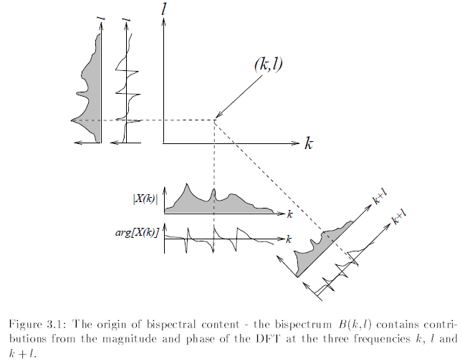

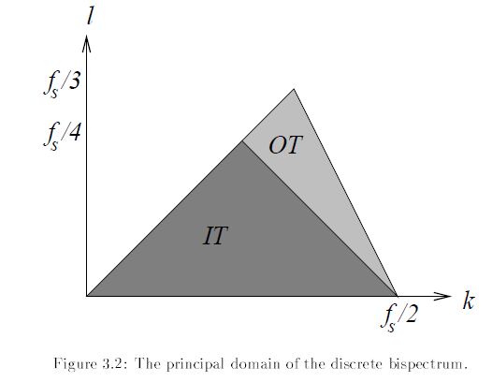

Power spectrum has a point of symmetry at the folding frequency $f_{s}/2$. Bispectrum has same kind of symmetry. Principal domain is the region the contains no redundant information, which is a triangular region. (IT=inner triangle and OT=outer triangle).

# Bispectrum estimation

M1 = stochastic signal. M2 = mixture of deterministic (sinusoidal) and stochastic signals. Direct vs. indirect methods (periodogram averaging vs. cumulant estimation). Here direct method is used.

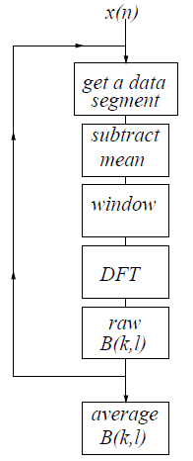

Signals conforming to M1:

* Smoothed bispectrum estimator is asymptotically complex normal (real and imaginary part are both normally distributed) and asymptotically independent (estimate at $(k,l)$ independent to $(k±1,l±1)$).
* Bispectral estimates are asymptotically unbiased (as data length increases, estimate tends towards true bisepctrum)
* $Var\left(\hat{B}\left(k.l\right)\right)∝P\left(k\right)P\left(l\right)P(k+l)$. Suppose signal has more energy at $f_{1},f_{2},f_{1}+f_{2}$ than at $g_{1},g_{2},g_{1}+g_{2}$, then the bispectral estimate $\hat{B}(k,l)$ will have higher variance at $(f_{1},f_{2})$ simply due to the energy difference.
* Since variance is energy dependent, bispectral estimate measures 2nd order and 3rd order properties. Need to try remove the second order sensitivity. One way is to pre-whiten the signal prior to bispectral analysis. More common way is to propose a new measure, called the skewness function
$${\hat{s}}^{2}\left(k,l\right)=\frac{{\left|\hat{B}\left(k,l\right)\right|}^{2}}{\hat{P}(k)\hat{P}(l)\hat{P}(k+l)}$$

* Skewness function estimate would have flat variance if denominator was known exactly.

Signals conforming to M2:

* Do not conform to the statistical properties described above.
* Mean and variance of bispectral estimates depends on the relationships between frequencies of the component sinusoids.
* Noise free case is simplest.

Alternative normalization is

$$b^{2}\left(k,l\right)=\frac{{E[\left|B\left(k,l\right)\right|}^{2}]}{E\left[S\left(k,l\right)\right]E[P\left(k+l\right)]}$$

which can be estimated as

$${\hat{b}}^{2}\left(k,l\right)=\frac{{\left|\hat{B}\left(k,l\right)\right|}^{2}}{\hat{S}\left(k,l\right)\hat{P}(k+l)}$$

This is the normalised bispectrum, or squared bicoherence, which has the same approximately-flat variance that the skewness function has. Unlike the skewness function, it is bounded between zero and one.

Other normalizations are the Kravtechenko-Berejnoi estimate,

$${\hat{b}}_{KB}\left(k,l\right)=\frac{{\left|\hat{B}\left(k,l\right)\right|}^{2}}{{\left(\sum_{i=0}^{K-1}{\left|X_{i}\left(k\right)X_{i}\left(l\right)X_{i}^{*}(k+l)\right|}\right)}^{2}}$$

which has the advantage of the arguments of the denominator are symmetric under perturbations. Not used extensively. Another one is amplitude-only (AO) and phase-only (PO) measures,

$$b_{PO}\left(k,l\right)=\frac{1}{K}\sum_{i=0}^{K-1}{\frac{X_{i}\left(k\right)X_{i}\left(l\right)X_{i}(k+l)}{\left|X_{i}\left(k\right)X_{i}\left(l\right)X_{i}(k+l)\right|}}.$$

# Properties of bispectrum

* Bispectrum of a Gaussian signal is identically zero
* Bispectrum of a linearly filtered Gaussian signal is identically zero
* Bispectrum of a non-Gaussian signal is blind to additive Gaussian noise
* Bicoherence of signal conforming to M1 or M2 is generally not blind to additive Gaussian noise
* If signal is filtered by a linear filter, then the magnitude of the normalised bispectrum is unchanged, provided that there are no zeros on the unit circle
* Skewness function of linearly filtered non-Gaussian iid signals is flat
* If signal is filtered by a linear-phase filter, the biphase information is unchanged
* Skewness function of a non-Gaussian M1 signal which has been passed through a nonlinear filter may not be flat.
* Bicoherence of a harmonic M2 signal peaks if the signal phases $ϕ_{1}$, $ϕ_{2}$ and $ϕ_{3}$ at frequencies $f_{1}$, $f_{2}$, $f_{3}=f_{1}+f_{2}$ respectively have the relation $ϕ_{3}=ϕ_{1}+ϕ_{2}$. (Quadratic phase coupling)

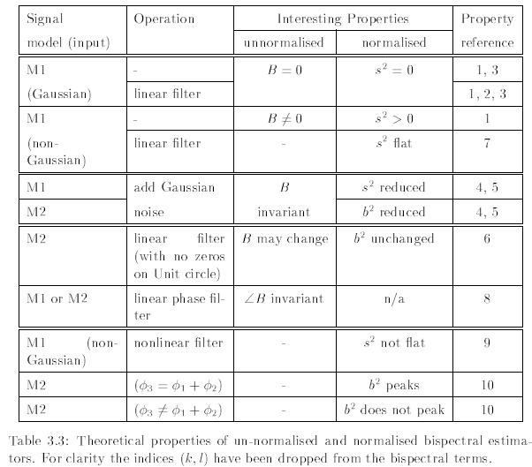

# Estimation Issues

* Issues regarding choice of window, comparison of theoretical and empirical results
* Data length issues. Bispectra have higher variances compared to PSD, so lengths that may be sufficient for PSD estimation might not be for bispectrum estimation
* Hinich et al. no. of segments should be at least as large as the DFT size ($K≥N$). For trispectrum estimation $K≥N^{2}$.
* Required length of data depends on how noisy the data is
* Theorem: If effects of leakage are ignored, then the peak bicoherence $b^{2}(k,l)$ corresponding to frequencies $f_{1},f_{2},f_{1}+f_{2}$, of an M2 signal consisting of three equal-amplitude coupled harmonics in variable levels of additive white Gaussian noise is

$$b^{2}\left(k,l\right)=\frac{1}{1+\frac{18}{N}{10}^{-SNR/10}+\frac{72}{N}{10}^{-2SNR/10}}$$

Peak bicoherence depends on the DFT size and SNR.

Bias and variance:

$$Bias≈\frac{1}{K}{\left(1-b^{2}\left(k,l\right)\right)}^{2} Variance≈\left(\frac{2b^{2}\left(k,l\right)}{K}\right){\left(1-b^{2}\left(k,l\right)\right)}^{3}$$

Replacing $b^{2}(k,l)$ with the above equation gives formulas for the bias and variance of the estimate in terms of the SNR, DFT size $N$ and number of data segments $K$.